**Assignment 2**

**(running application from differnt git branches)**

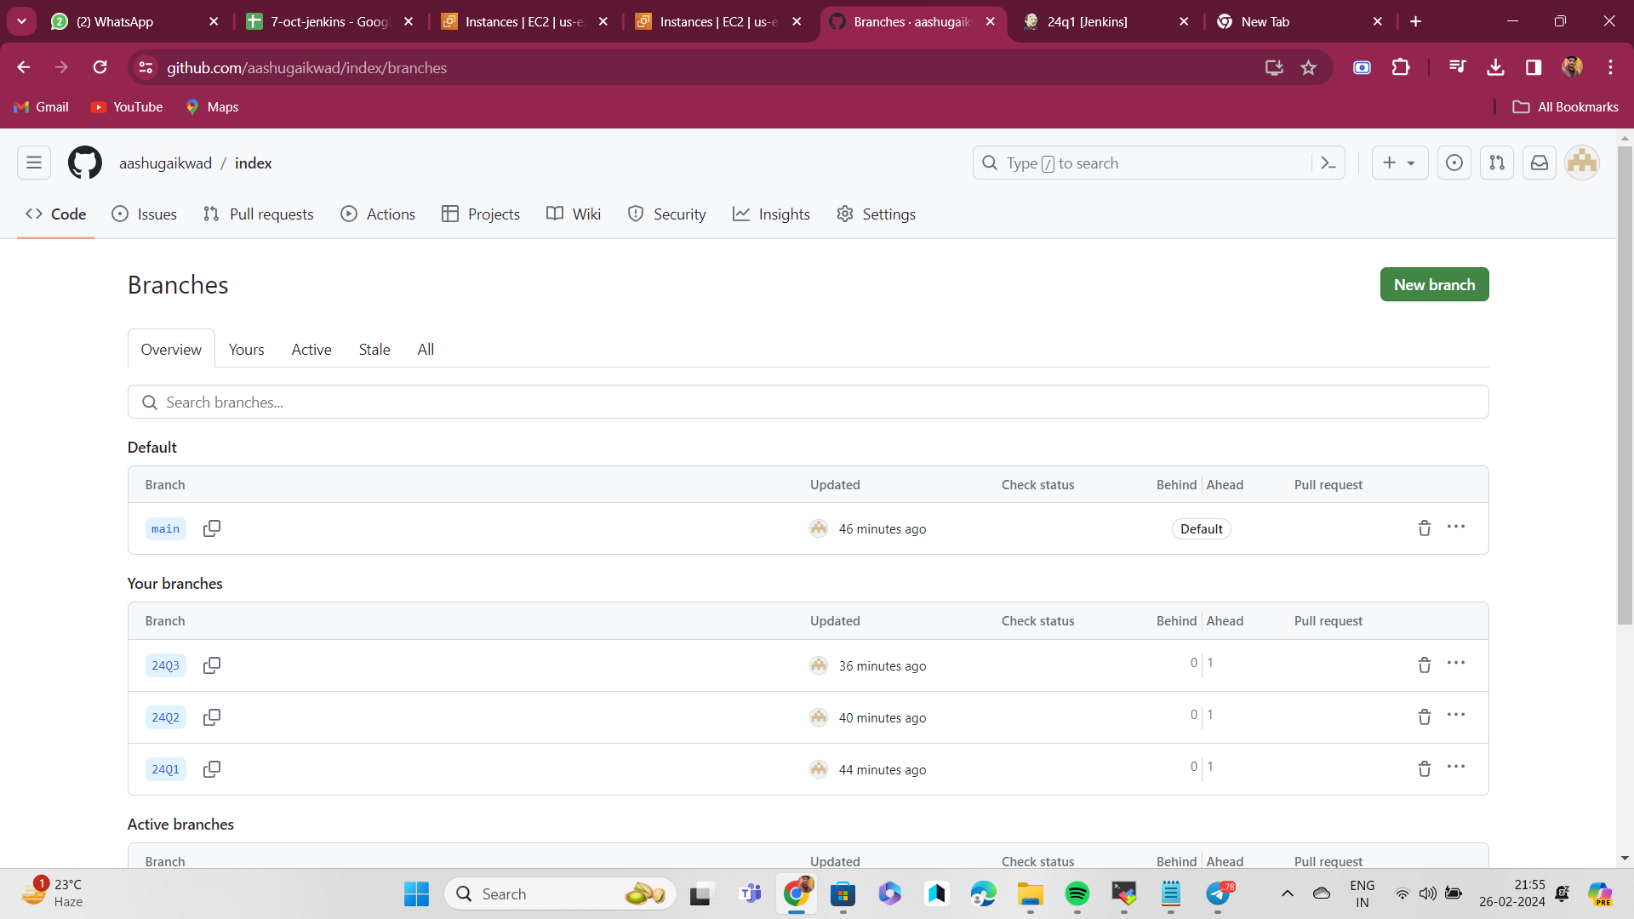

Making 3 branches from master branch

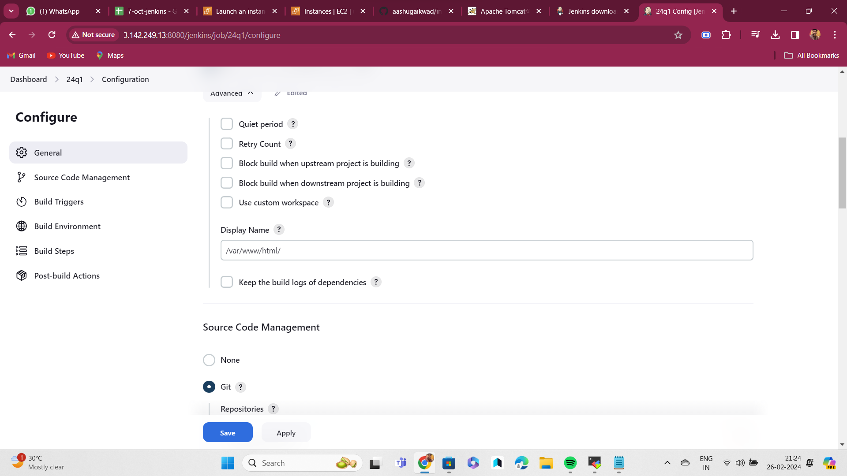

Seting custom home /var/www/html/

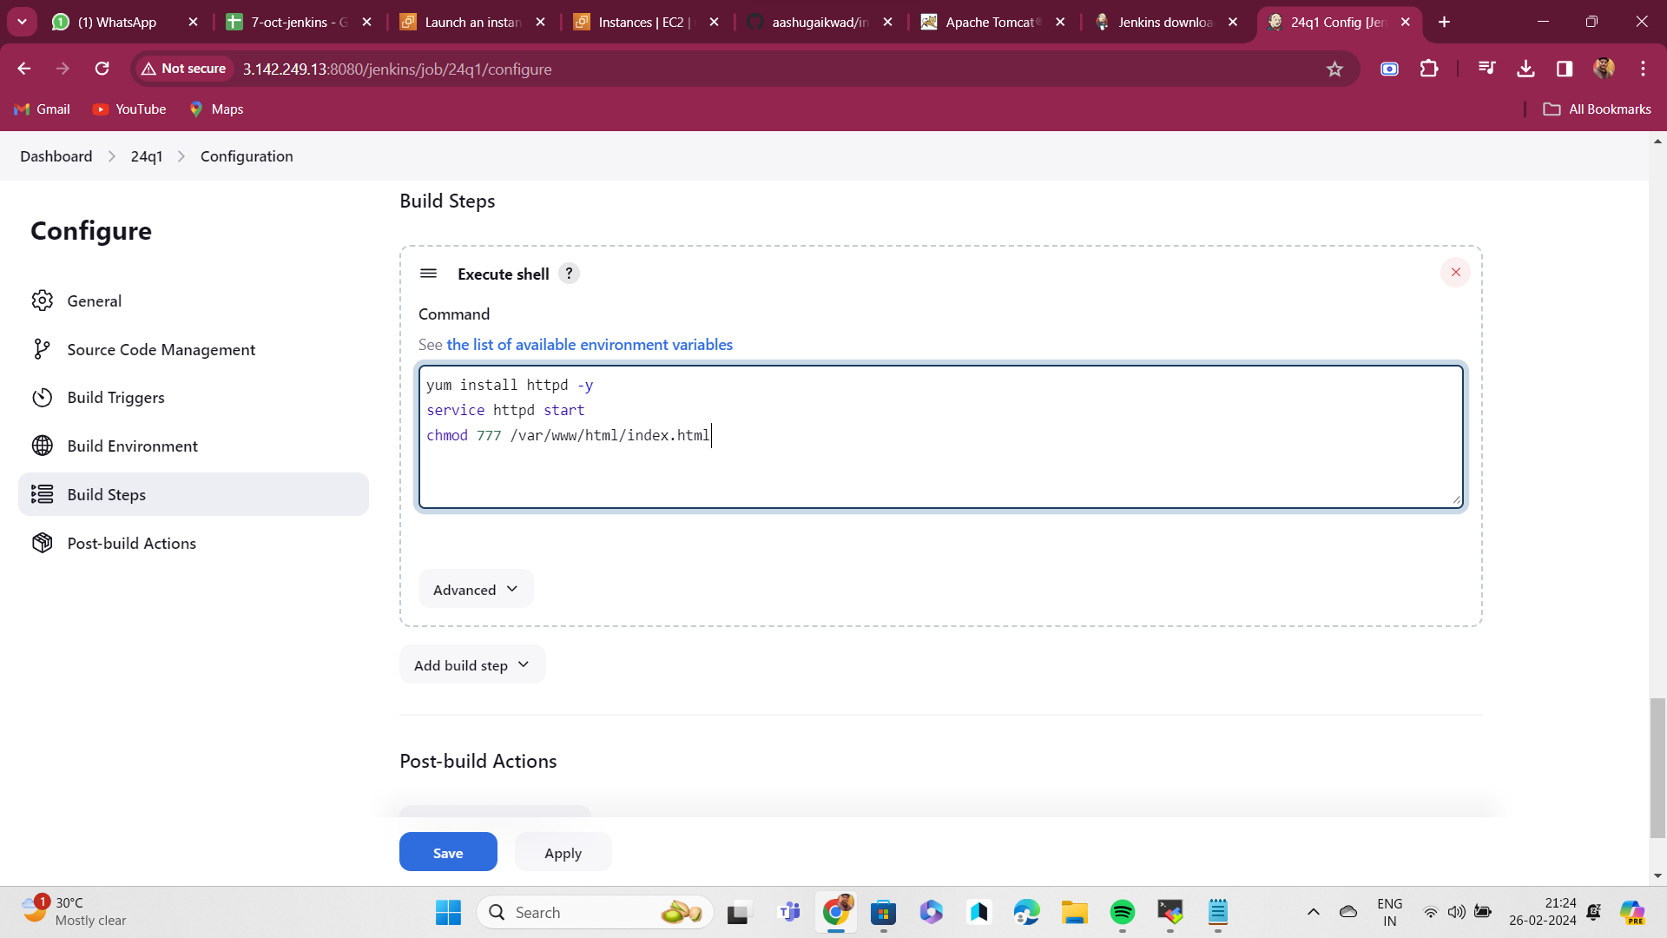

shript

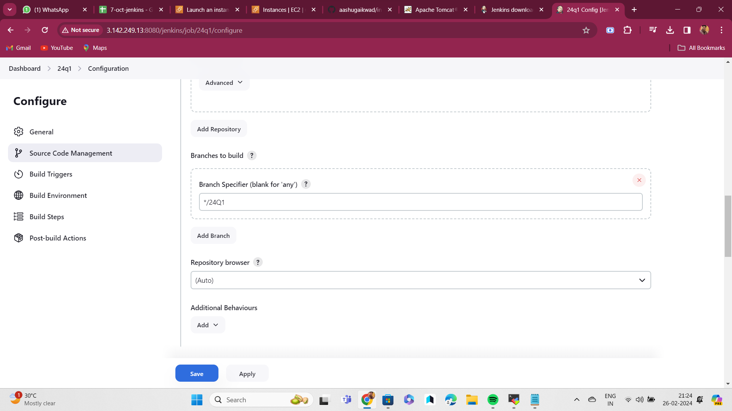Selecting git repo and branch

**Assignment 3**

**(compileing and deploying website via jenkins auto mation)**

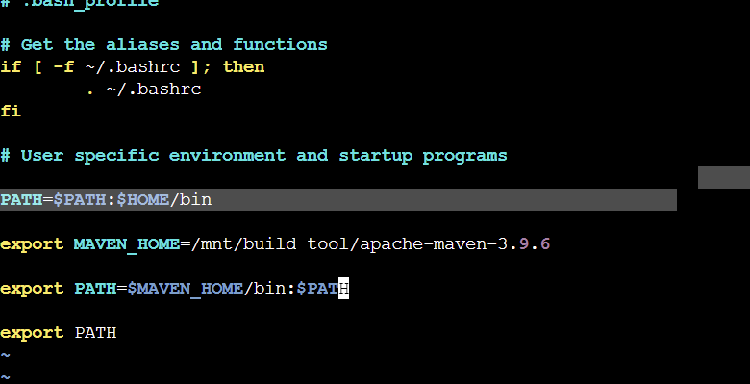Config mvn local environment

Attaching git repo were the pom file is present with credentials

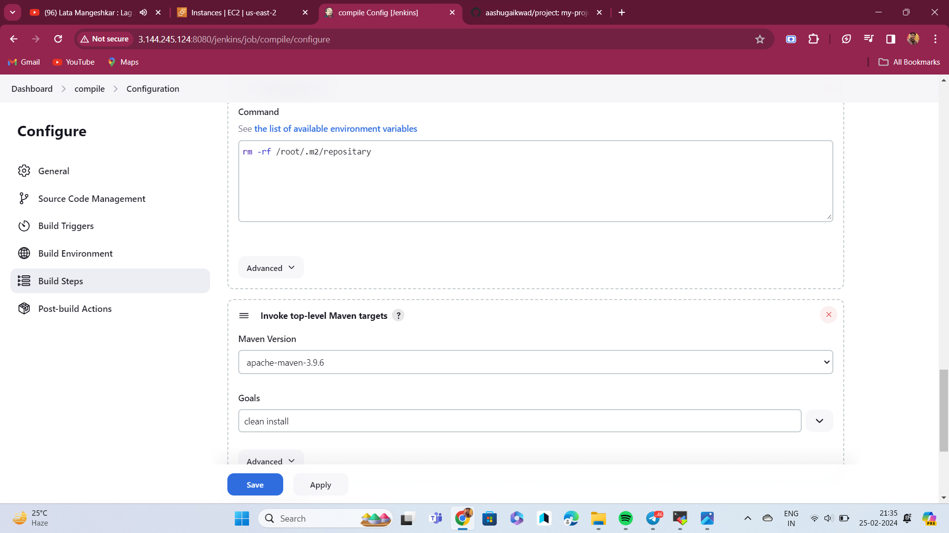Attaching maven and giving mvn command

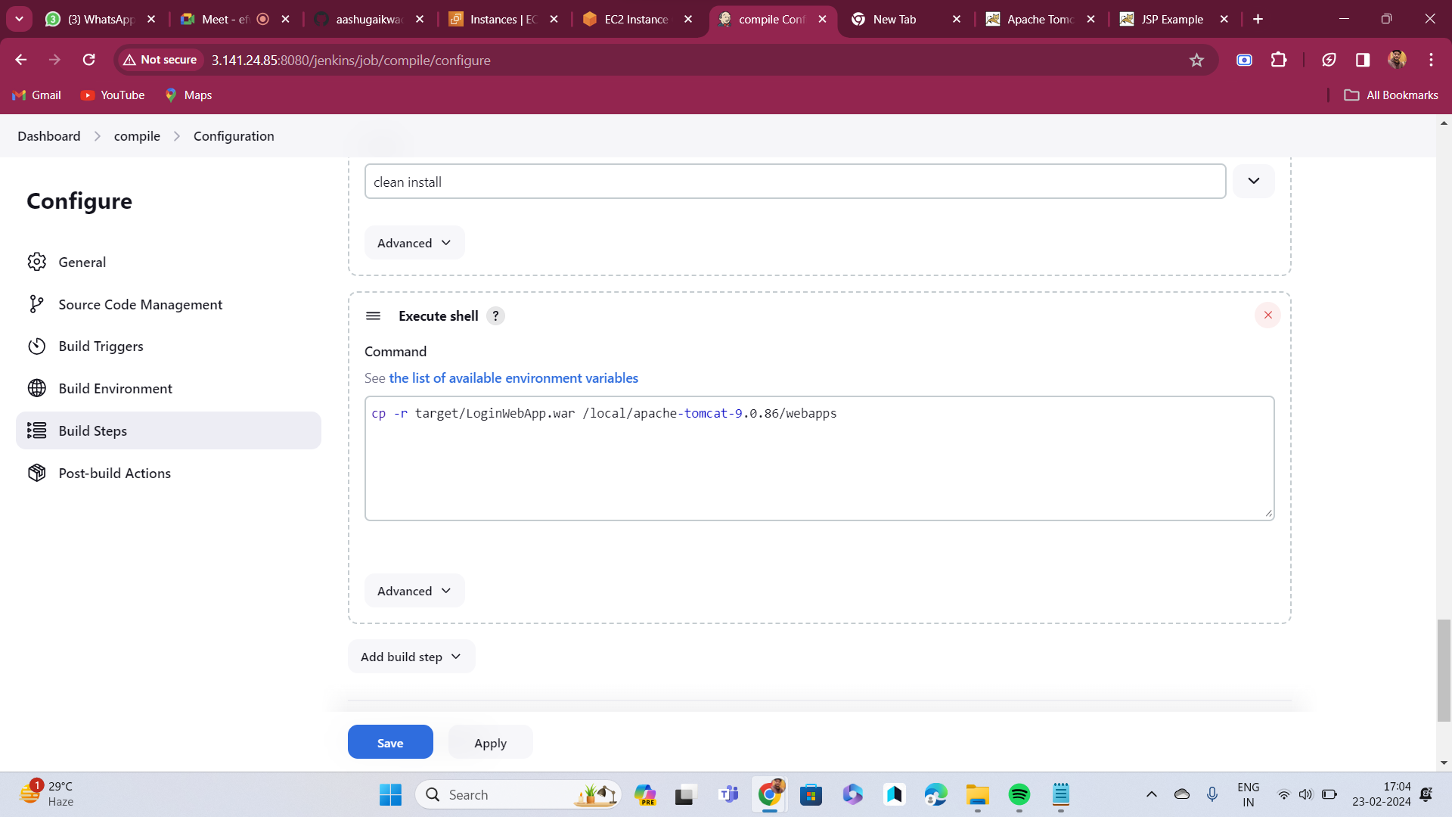

Moving war file to tom cat server

And deploying it

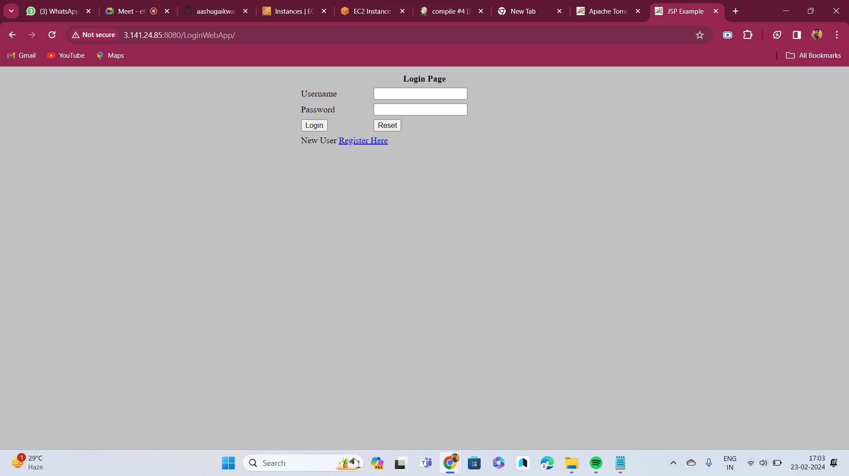

**Assignment 4**

**(compiling on one maching and deploing using different machine)**

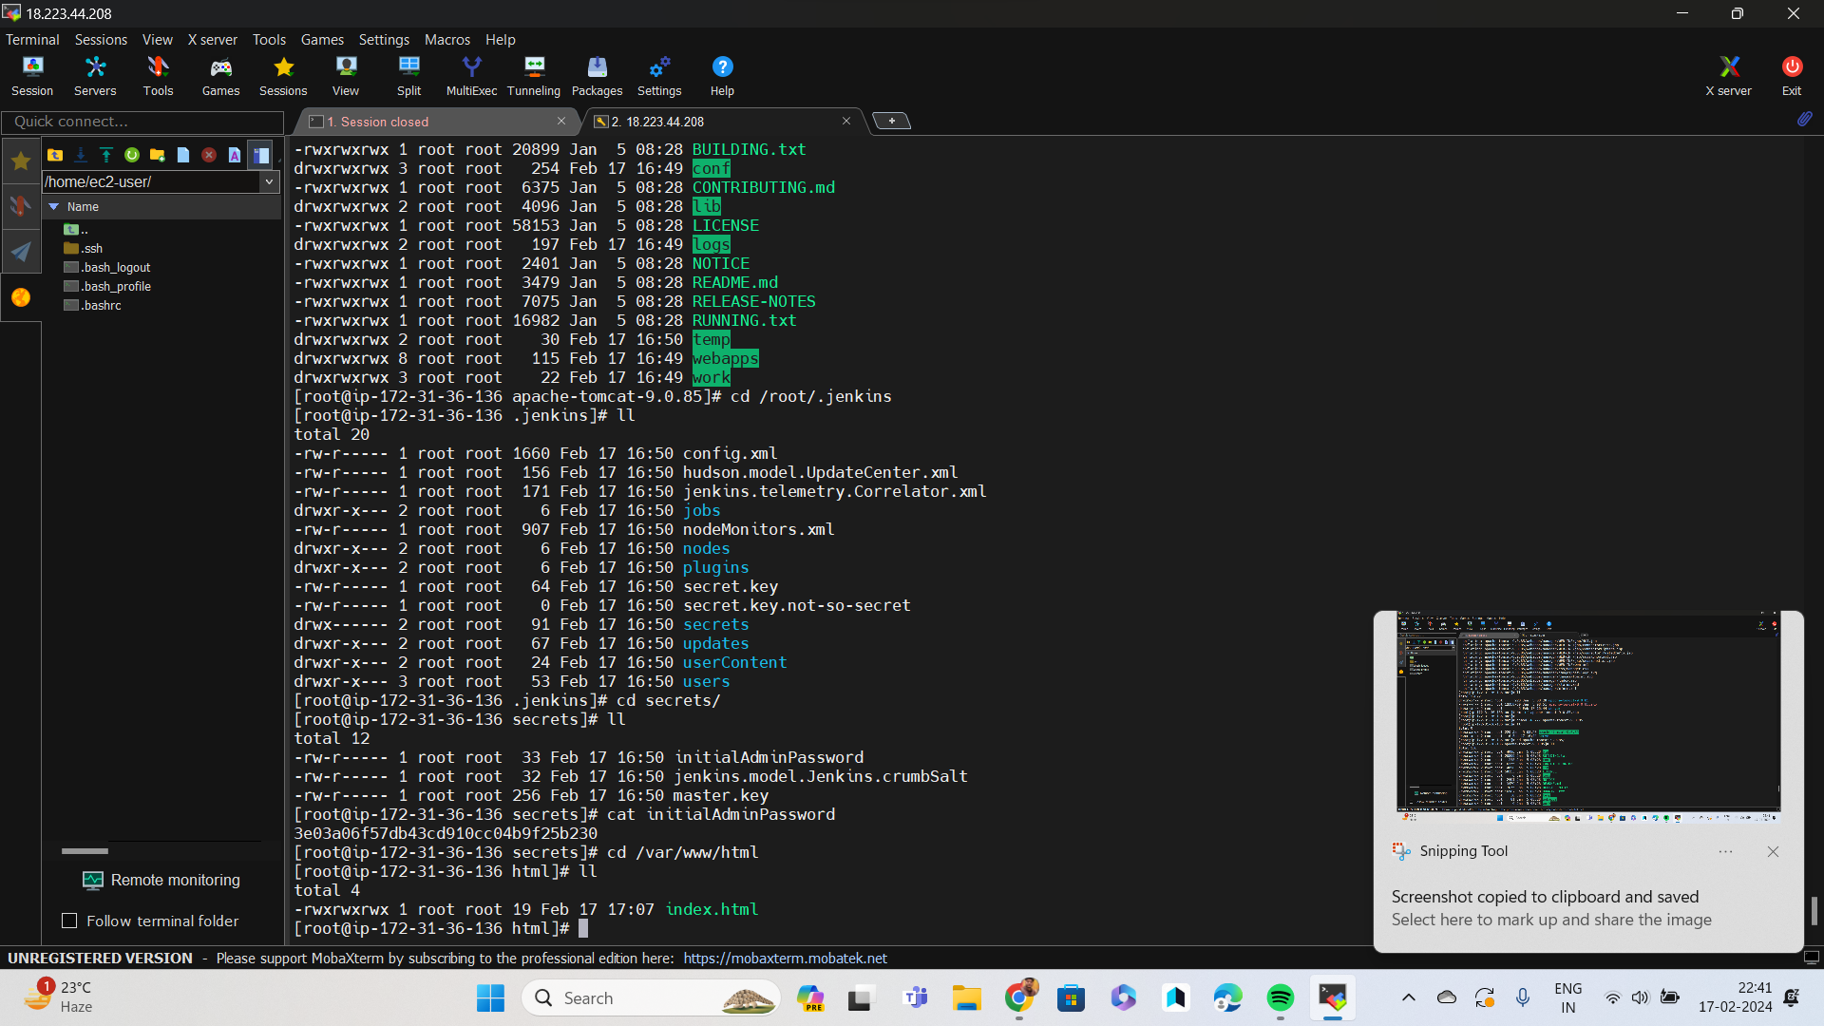

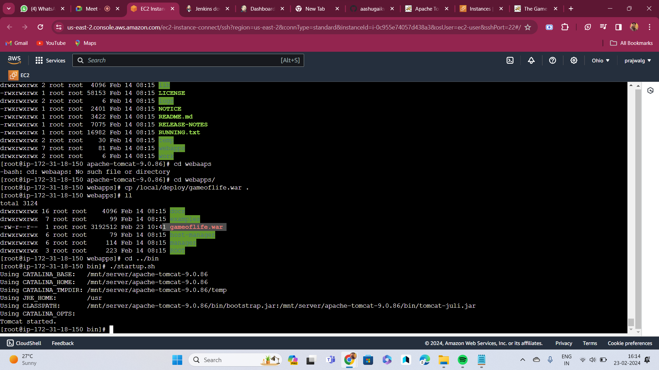

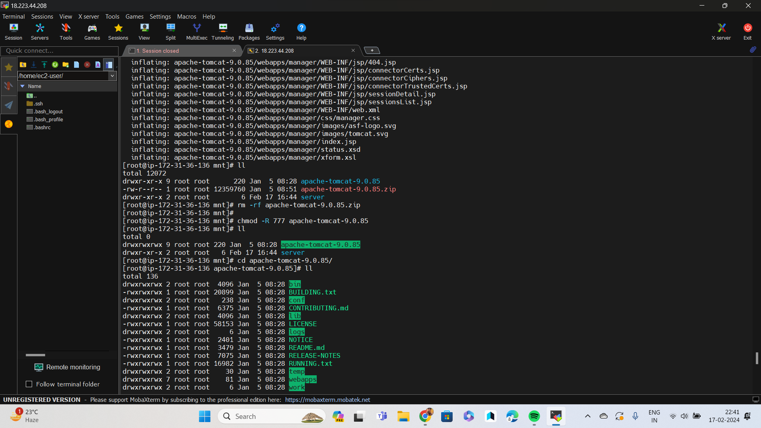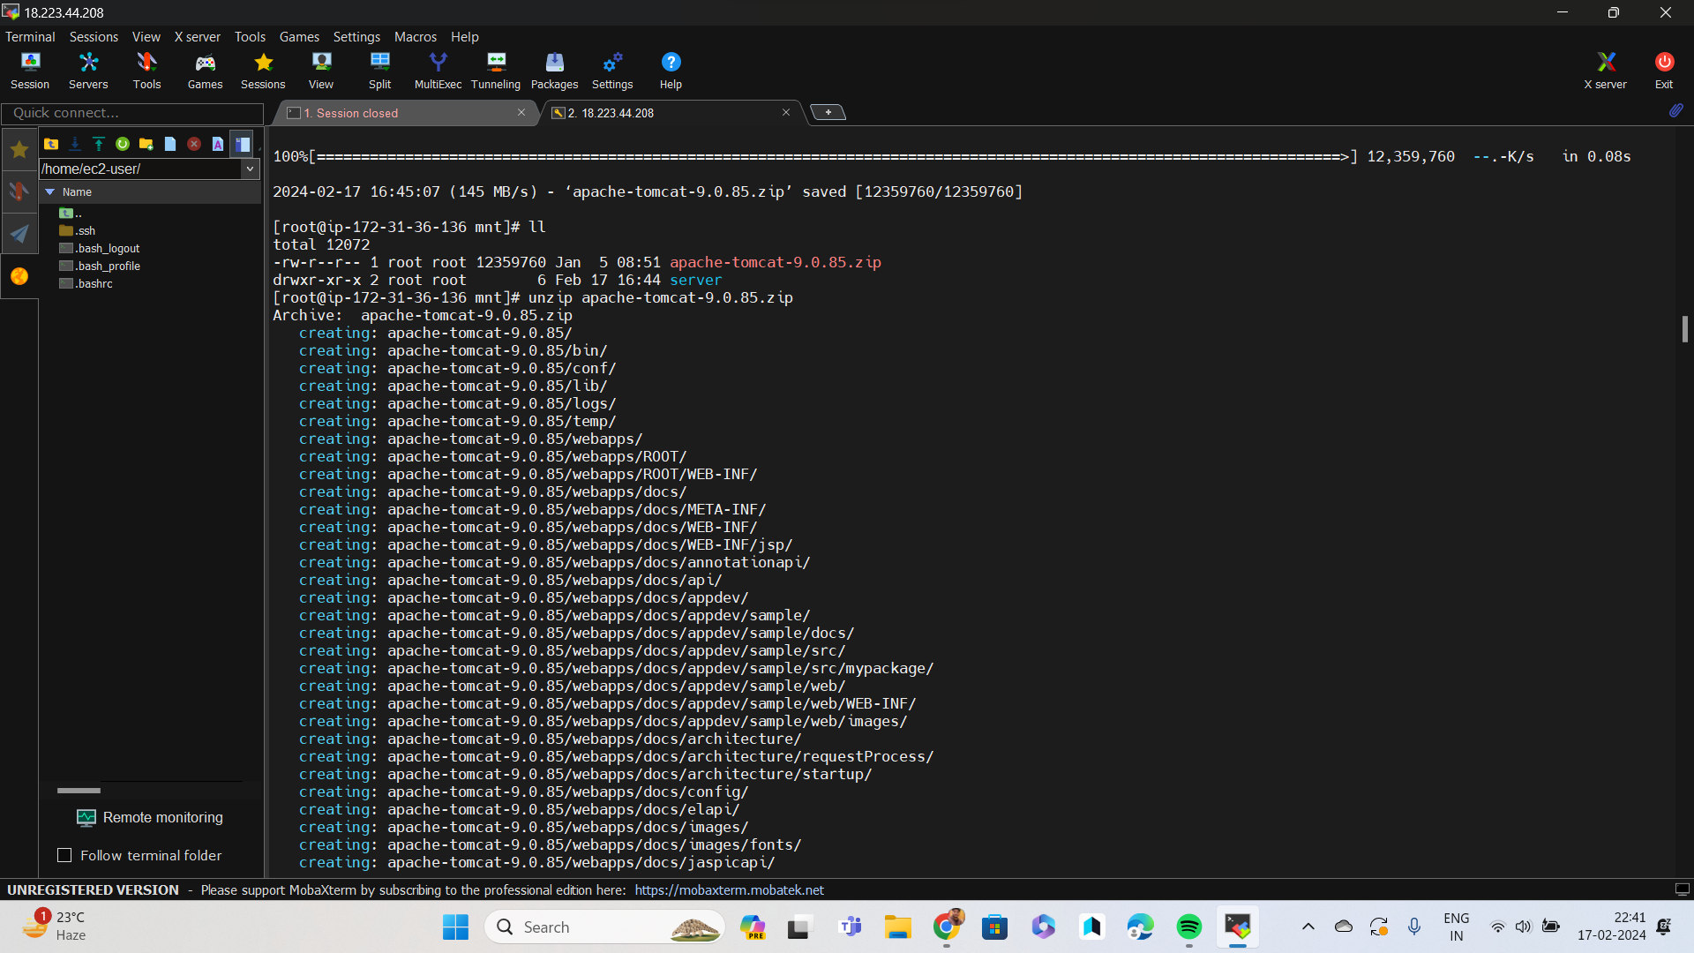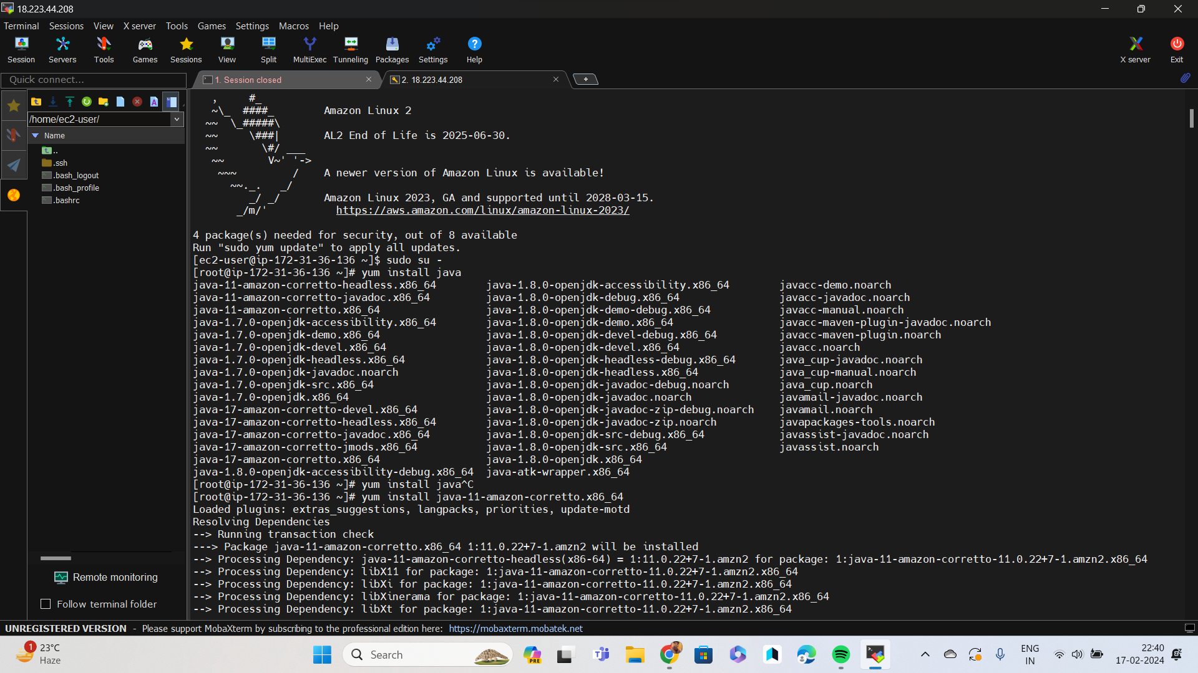

Steps

1 compiled code on 1st machine using maven

2. moved war file in git local repo

3. pushed it in remote repo

4 . pulled that file in 2nd machine

4 coppiled it in tomcat and deployed